**Futsal Management System**



Uttam Tamang

00172895

Computing Project

Level 5 Diploma in Computing

Softwarica College of IT and E-Commerce

Kathmandu, Nepal

04/01/2019

Table of Contents

**Chapter 1** 4

Introduction 4

Background of the project 4

Problem Statement 4

Aim and Objectives 5

Scope and Limitation 5

Scope 5

Limitation 5

Feature of the project 5

Development Methodology 7

Design Pattern 8

System Architecture 9

**Chapter 2** 10

Project Management 10

Risk Management 10

Work Breakdown Structure 11

Configuration Management 11

**Chapter 3** 13

Analysis 13

Requirement Analysis 13

Use Case Diagram 13

Architecture Diagram 15

1. Initial Class Diagram 15

**Class** 15

Class Notation 15

Purpose of Class Diagrams 15

**Chapter 4** 17

Design 17

Structural Model 17

1. Final Class Diagram 17

Behavioral Model 18

1. Activity Diagram 18

2. Sequence Diagram 21

UI Design 22

Database Design 24

**Chapter 5** 25

Implementation 25

**Chapter 6** 26

Testing 26

1. Unit Testing 26

2. Black Box Testing 26

Conclusion 36

References 36

# Chapter 1

# Introduction

Project that I am currently working on falls under L5DC’s Module Computing Project. Aim of this project is to reflect student’s learning over their three semester of study (L4DC and 1st semester of L5DC) and preparing them for real world project in their respective field of interest.

Futsal Management System is the project that I am working on. The system is all about keeping record of information about clients and their reservation or booking information. Information will be recorded in such a way that it will provide data availability and prevention from data duplication, thus providing systematic management of business process.

# Background of the project

Project that I am currently developing is mainly focused as solution for handling pre-booking of Futsal Field, that is made by respective customers. System will allow customer to place their booking according to date and time available. So, system will permit customer log in and displays information about date and time for that ground, cost for that ground before booking. As cost for the ground can be varies according to time.

Futsal Management System will be web-based application with **primary focus** of providing user friendly UI, which allows customer can access to application easily and place their booking procedure from anywhere and anytime. This automated system will reduce time consuming paper work and phone calls as well as stores important information in database securely and properly. Database will be kept secure and backup regularly so that efficiency could be maintained and data storing process will become easier.

# Problem Statement

Currently, organization is fully dependent upon general visit to management office and filling paper-based documentation or unnecessary amount of phone call for placing booking their booking to particular ground on particular time frame. The main problem with this system is that it is complex and time consuming for both management staff and client.

Consequently, booking process is not always easy for clients. Specially, doesn’t allows them to place their booking from anywhere and whenever they want. Because, if they want a reservation, they are bound to be visit in registration office and if they are known clients then they have to make phone calls which will never sure for correct and effective reservation.

So, mission of project has been to providing features which will minimize or completely remove these problems and maintain a healthy relationship among business process and clients.

# Aim and Objectives

**Following are the Aim and Objectives of project:**

**Aim**

* To maintain customer as well as employee Satisfaction.
* promote sport and healthy environment in society.

**Objectives**

* Firstly, all reservation system will made online as well as done from registration office.
* Reduce every possible manual task with automation system.
* User friendly UI design.
* Reliable and secure record system.
* Providing well facilitated sport ground at possible lower cost.
* Keeping record of user feedbacks and necessary Improvements.
* Providing reward system for customers as per their achieved milestones.

# Scope and Limitation

## Scope

As per problem statement of project, scope of project is providing functionality that meets requirements specified at problem statement. Which includes mainly about replacing manual task with automated system or other simpler ways. For example, storing record of client’s information with form filling at registration office with physical visit should replace with web-based registration from anywhere user wants. Similarly, good UI design, easy ground reservation, accept and rejection of reservation made and automatic reservation removing functionality as per rules and policy are scope of the project.

## Limitation

Current project in developed with such vision that it will manage reservation and record keeping/tracking functionalities. However, projects lack upon accepting online payment system. Which requires clients for short visit in office for payment of their reservation.

# Feature of the project

Features of the project includes:

* User registration and login
  + System user can register them self with personal information in system and then they will be provided system access service for making reservation.
  + User can be system admins as well and Clients/Customers.
* Check available timeslots
  + Clients that wants to make reservation will be provided with list of available timeslots for ground reservation.
  + Reserved timeslots will be displayed as “Booked timeslot’ and restrict from making booking in that time.

* Check respective cost according to time
  + As cost for the ground can be varies according to time. Clients will be informed with cost for that perticular timeframe.
* Place booking (Client)
  + It’s a primary goal of system in which client who had login to system can make reservation for ground at available time.
* Display their booking
  + Reservation made by that clients can be displayed in their reservation page.
* View booking made by clients (Admin)
  + In admin dashboard, admin will be presented with list of reservation that have been made by every client.
* Manage personal information’s
  + System will have service for updating personal information.
  + For example, changing name, phone number, address etc.

# Development Methodology

Waterfall methodology is use for development of this project. Waterfall model is commonly used software development methodology guaranteeing the success of the working software. It’s consisting of different phases which ensures your success development process of the project.

Advantage of waterfall model includes:

* Easy to understand and use
* Fixed and clear phases and rules that you have to follow when you move from one phase to another.
* Easy maintenance
* You can review your progression over time
* Well documentation

Diagrammatic representation of waterfall model is given below: 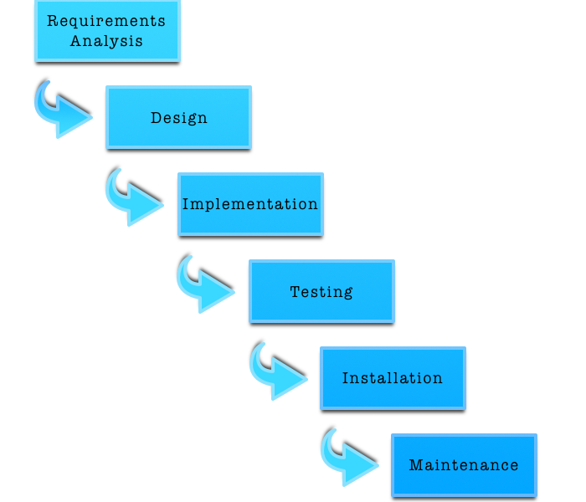

**Different phases of waterfall model and their goals:**

**Requirement analysis**

* System requirements that need to be established are completely captured and documented.

**System Design**

* With help of first phase of waterfall model system design is prepared in this phase and then overall system architecture is prepared.

**Implementation**

* In this phase, system is developed in small programs which are called units.
* This phase is also known as **Development and Coding**.

**Testing**

* Now, those units get integrated in this phase and perform testing in order to prevent from defects/faults and failure.

**Deployment/Installation of system**

* After testing now software is installed or get released.

**Maintenance**

* After installation of software, identified issues and defects gets resolved with release of patches as well as newer versions of that software.

# Design Pattern

Generally, design patterns are those solution which helps in commonly occurring problem in software design. Usually, they act as template explaining how to solve those problems.

**MVC (Model View Controller) design pattern** is the one which I have choose as it is commonly used architectural pattern for UI design.

It divides system into three different parts yet interconnected with each other and allocate specific responsibilities.

Different parts and their responsibilities:

**Model**

* Central part and independent to UI
* It manages data, logic, rules of the application
* It receives data od an application with help of controller

**View**

* Basically, view handles UI design of an application

**Controller**

* It accepts user inputs and translate it as command for Model or View.

Advantage of MVC design pattern are as follows:

* It allows simultaneous development of divided parts i.e. Model, View and Controller
* Low coupling in system architecture
* High cohesion in code structure
* It facilitates multiple view for model.

# System Architecture

Structural design of a system that automates work is known as system architecture. Also, it can be defined as conceptual model which represents structure, behavior and view of your system. It involves system components and developed sub-system together to implement complete system.

In this project I am going to use 3-tire system architecture which is also commonly known as Client-Server architecture in this architecture functional process logic, data access, data recording system and UI design are developed and maintained as independent modules on separate platform. (Anon., 2018)

**Three layers of 3-tier architecture are:**

* **Presentation layer**

Displays view of your system i.e. UI. It sends contents to browser in form of HTML/CSS/JS.

* **Application layer**

Application server is used and processes business logic for an application.

* **Data layer**

It is simply Database management system, which lets you access over application data.

**Diagrammatic representation of 3-tire system architecture is:**

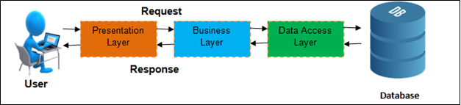

Figure 3 3-Tier Architecture

**Why 3-tire over 2-tire system architecture?**

2-tier architecture involves direct interaction between client with server but 3-tire includes business layer in between client and server thus maintaining extra layer of security. The reason behind choosing 3-tire system architecture over 2-tire system architecture is because, 3-tire architecture provides greater scalability and data security. And client data availability is very important in present technology.

# Chapter 2

# Project Management

## Risk Management

|  |  |  |  |  |  |
| --- | --- | --- | --- | --- | --- |
| **SN** | **Risk** | **Likelihood** | **Consequences** | **Impact** | **Solution** |
| 1. | Insufficient resources | 2 | 3 | 6 | Keep each and every resource that you are going to use in a sufficient amount. |
| 2. | Server failure | 1 | 5 | 5 | Facility of a backup system can be done. Either cloud based or physical. |
| 3. | Delay in Development | 2 | 5 | 10 | Strict scheduling and planning with collaboration among team will lead to quicker development. |
| 4. | Badly Designed UI | 1 | 4 | 4 | With preforming good requirement gathering as well as collaborative UI designing between user and Developer be solution for this. |
| 5. | Uncertain Growth of requirements | 1 | 4 | 4 | Having certain level of contract between client and developer and good requirement analysis solve this issue. |
| 6. | Overly Featured | 2 | 2 | 4 | By preventing developer from show off their skill by adding unnecessary features. |
| 7. | Financial Issues | 1 | 4 | 4 | Always schedule and planning budget accordingly will help with this situation. |
| 8. | Outdated Developer’s Skill | 1 | 5 | 5 | Employee training and encouraging for learning new skill will solve this problem. |

## Work Breakdown Structure

Work breakdown structure is simply a process of breaking down your project into smaller manageable parts, so that you can understand and manage easily as well as more effectively. Generally, WBS is represented as Tree like structure with different task and their interrelated sub tasks.

Diagrammatic representation of WBS scheduling is:

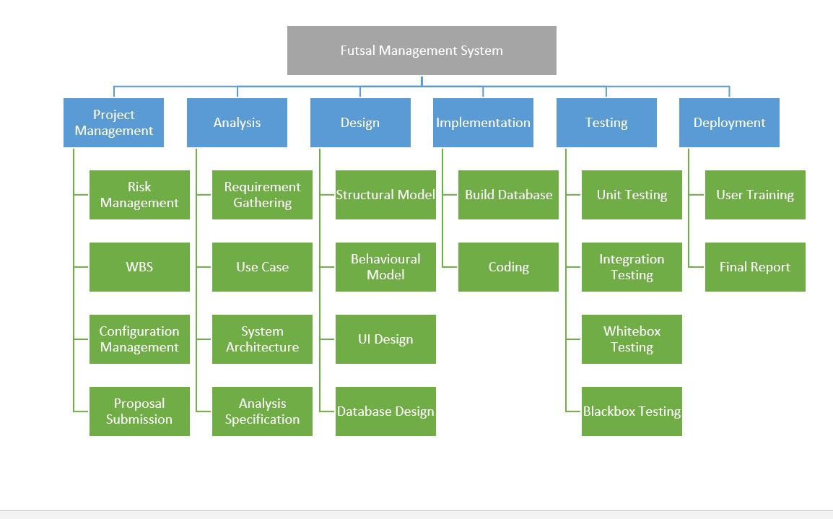

## Configuration Management

Configuration management of a project refers to collection of processes, activities, tools and methods which is performed by professionals to manage items and resources during the project life cycle. Usually, administrators or professionals uses configuration management to authenticate a change made during to one configuration item has on other systems. These items could be both hardware or software even documentations.

In my project I have used git for backup my project progression and documented associated with it.

Also, git provide **version control** mechanism which will be provide extra edge in development, maintenance and backup system. Version control simply means a system that records changes in a file or collection of files over time so that you can recall specific version later.

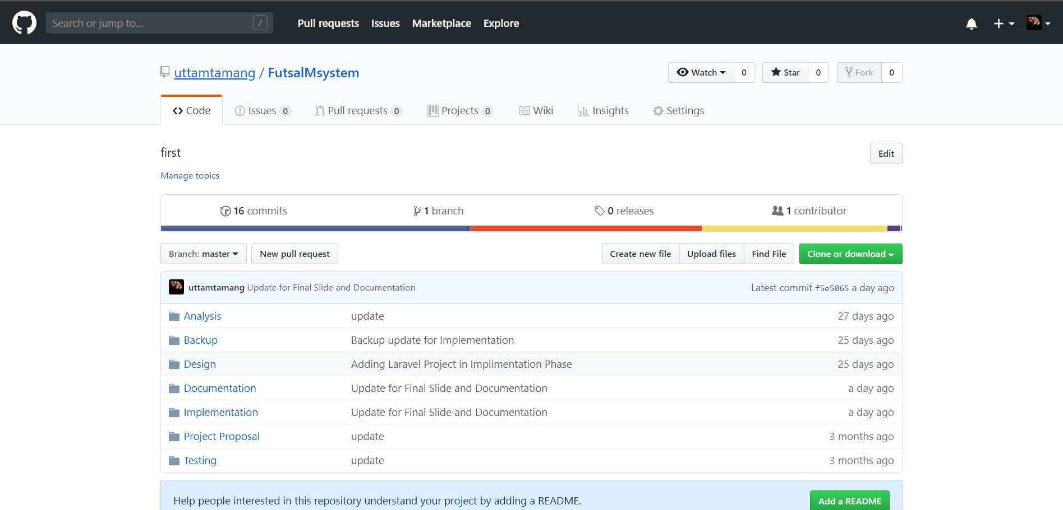

# Chapter 3

# Analysis

## Requirement Analysis

|  |  |  |
| --- | --- | --- |
| **Functional/Non-Functional(F/NF)** | **Requirements** | **MoSCoW** |
| F(R1) | Online Registration System | M |
| F(R2) | Login System | M |
| NF(R3) | Efficient Application | M |
| F(R4) | User friendly UI design | S |
| NF(R5) | Security | M |
| F(R6) | Provide information about timeslots (available/unavailable) for Reservation | M |
| F(R7) | Database System | M |
| F(R8) | Update Facilities for profile information’s and reservations | M |
| F(R9) | Allows user to remove reservations as per their needs | M |
| F(R10) | Prevent from reservation duplication | M |
| F(R11) | Billing System | S |
| F(R12) | Reward system for Customer that reach reservation milestones | C |
| NF(R13) | System Database should handle any amount of transaction data. i.e. Scalability | C |
| NF(R14) | System should ensure Availability | S |
| NF(R15) | Reliable and Accurate processing | S |

## Use Case Diagram

A use case is a methodology used in system analysis to identify, clarify, and organize system requirements. The use case is made up of a set of possible sequences of interactions between systems and users as known as **Actor** in a particular environment and related to a particular goal. It consists of a group of elements (for example, classes and interfaces) that can be used together in a way that will have an effect larger than the sum of the separate elements combined. The use case should contain all system activities that have significance to the users.

Characteristics of use case diagram are:

* Use case diagrams do not show interactions between actors.
* Actors are represented by stick figures.
* Actions are represented by ovals in which a broad description of the process is placed.
* A specific interaction is defined as a line which connects the actor and the action they can perform.

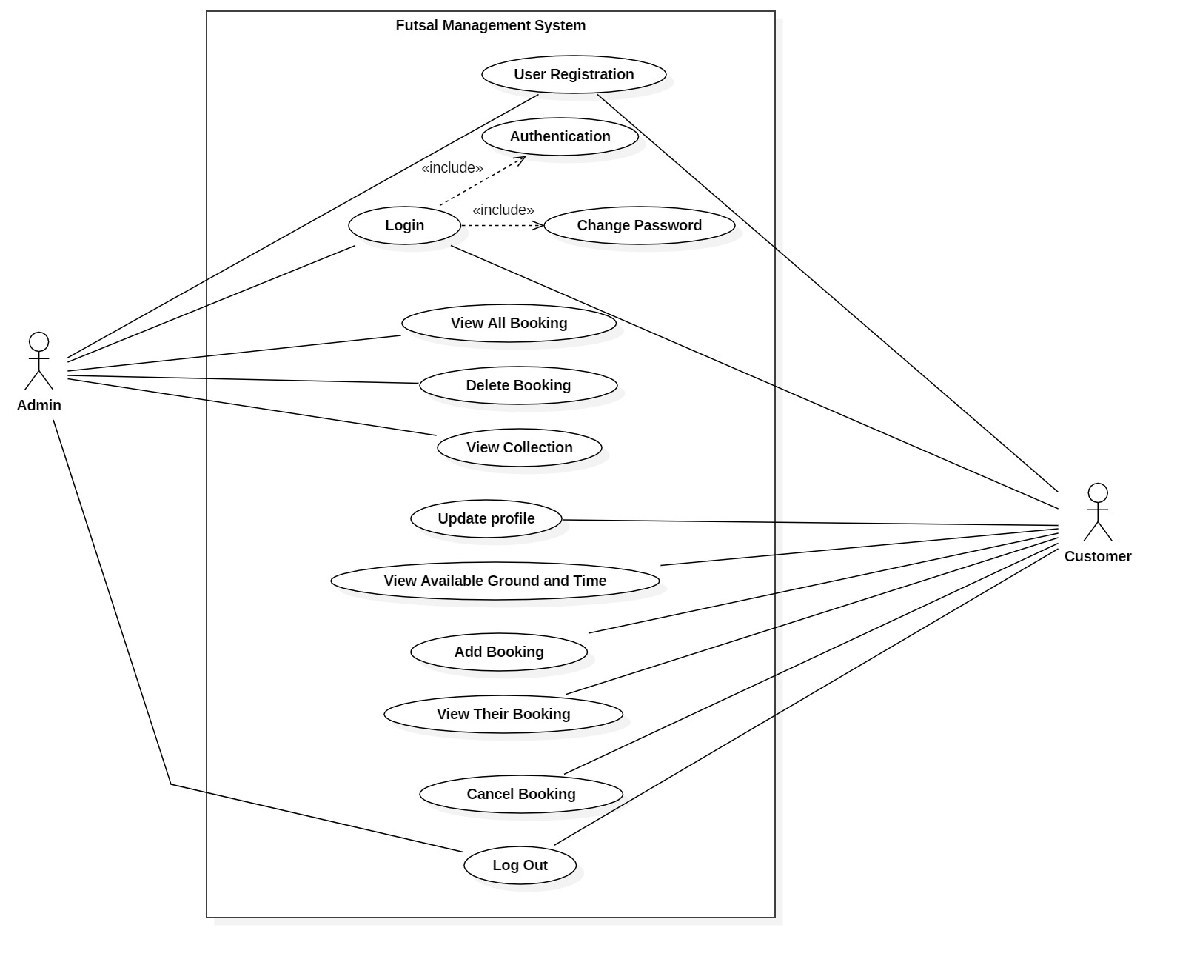

## Architecture Diagram

## Initial Class Diagram

**Class**

A description of a group of objects all with similar roles in the system, which consists of:

* Structural features (attributes) define what objects of the class "know"
  + Represent the state of an object of the class
  + Are descriptions of the structural or static features of a class
* Behavioral features (operations) define what objects of the class "can do"
  + Define the way in which objects may interact
  + Operations are descriptions of behavioral or dynamic features of a class

Class Notation

A class notation consists of three parts:

1. Class Name
   * The name of the class appears in the first partition.
2. Class Attributes
   * Attributes are shown in the second partition.
   * The attribute type is shown after the colon.
   * Attributes map onto member variables (data members) in code.
3. Class Operations (Methods)
   * Operations are shown in the third partition. They are services the class provides.
   * The return type of a method is shown after the colon at the end of the method signature.
   * The return type of method parameters are shown after the colon following the parameter name.
   * Operations map onto class methods in code

**Class Diagram**

In software engineering, a class diagram in the Unified Modelling Language (UML) is **a type of static structure diagram** that describes the structure of a system by showing the system's classes, their attributes, operations (or methods), and the relationships among objects.

Purpose of Class Diagrams

* Shows static structure of classifiers in a system
* Diagram provides basic notation for other structure diagrams prescribed by UML
* Helpful for developers and other team members too
* Business Analysts can use class diagrams to model systems from business perspective

**Initial Class Diagram**

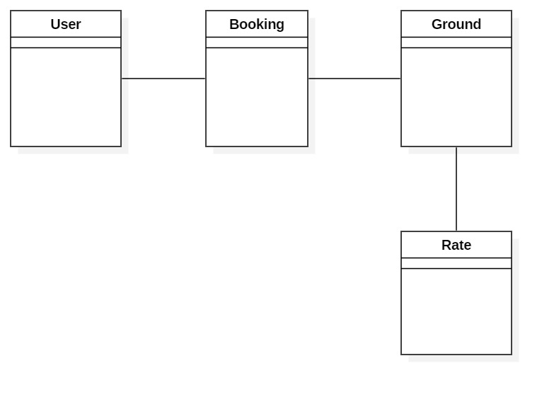

# Chapter 4

# Design

# Structural Model

## Final Class Diagram

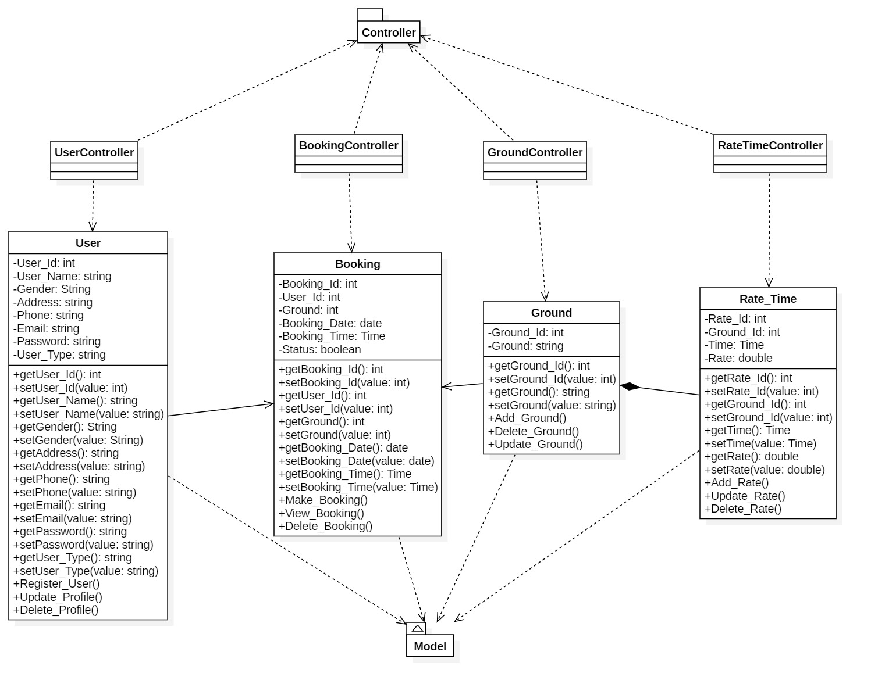

# Behavioral Model

## Activity Diagram

Activity diagrams are known as **workflow diagrams**. They are much like flow-charts, except more structured.

In Unified Modeling Language (UML), an activity diagram is a graphical representation of an executed set of procedural system activities and considered a state chart diagram variation. Activity diagrams describe parallel and conditional activities, use cases and system functions at a detailed level.

An activity diagram is used to model a large activity's sequential work flow by focusing on action sequences and respective action initiating conditions. The state of an activity relates to the performance of each workflow step.

Following are the Notational Elements used in Activity Diagram:

* **Swim Lane**

Used to indicate which actors or objects are responsible for the action. They are indicated by a series of lines partitioning the diagram.

* **Initial Node**

The starting point for the diagram. This is represented by a single filled circle.

* **Activity Final Node**

The termination point for the activities. There may be several of these in a diagram. This is a filled circle surrounded by a border.

* **Flow**

The flow represents the order in which activities are performed. Indicated by arrows.

* **Fork**

A fork indicates parallel processing – activities that can be undertaken at the same time. A fork is indicated by a thick bar where one flow enters and multiple flows leave.

* **Join**

A join indicates the end of parallel processing, and is indicated by a thick bar where multiple flows enter and only one leaves.

* **Decision**

A decision represent a choice that must be taken, and is represented as a diamond with a single flow entering and one or more flows leaving.

* **Activity**

An activity is the baseline step in an activity diagram, and is represented by a rounded oval. An activity is any logically discreet action that must be taken throughout the course of the activity.

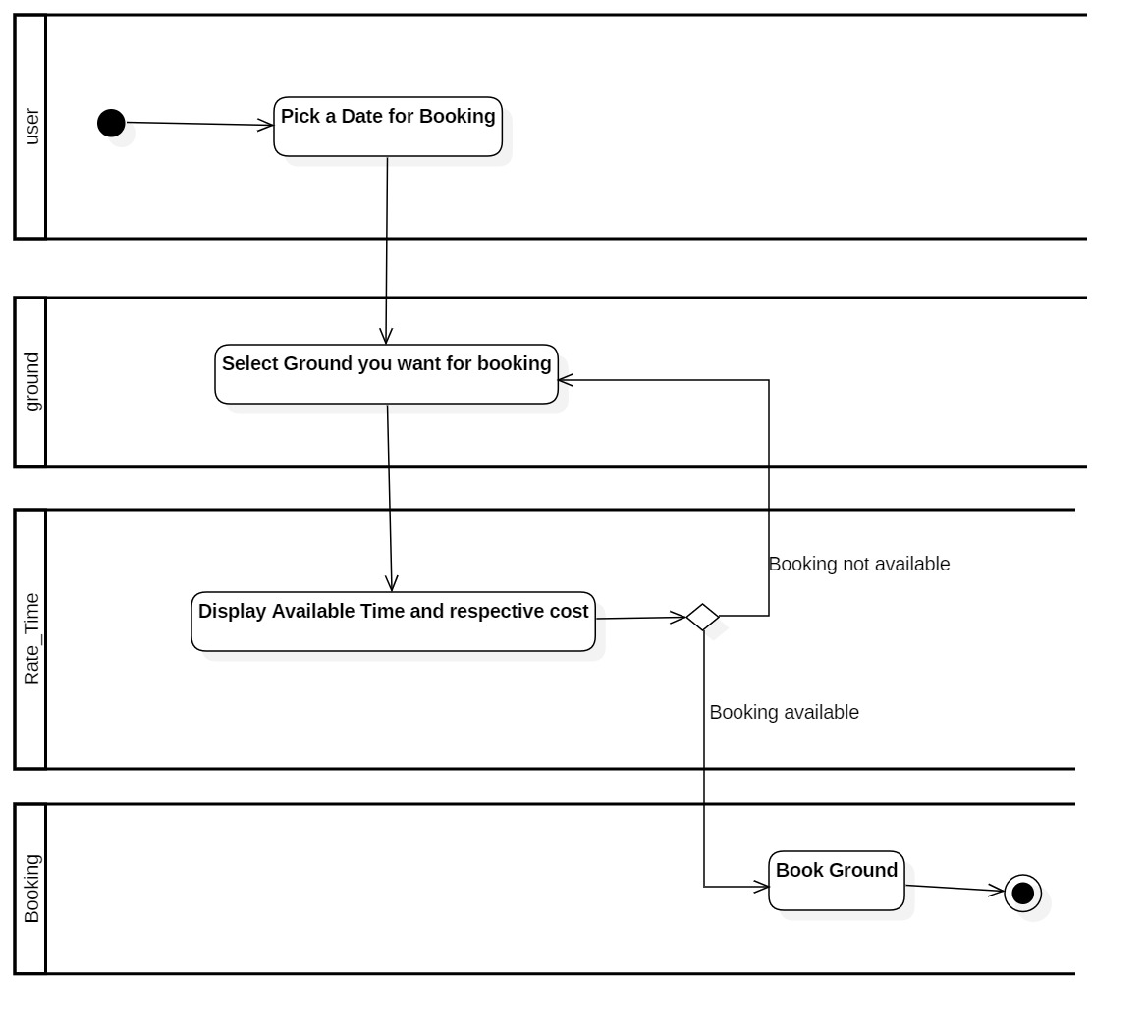

**Activity Justification**

This activity explains about process that user perform in order to make their futsal booking. Firstly, user gets log in and after that he/she pick a date for their booking and select ground that they want. After that system will display booking time slots for that ground. Now they will have a choice if they can make their booking or not. Finally, they can book a ground as their choice and end this activity.

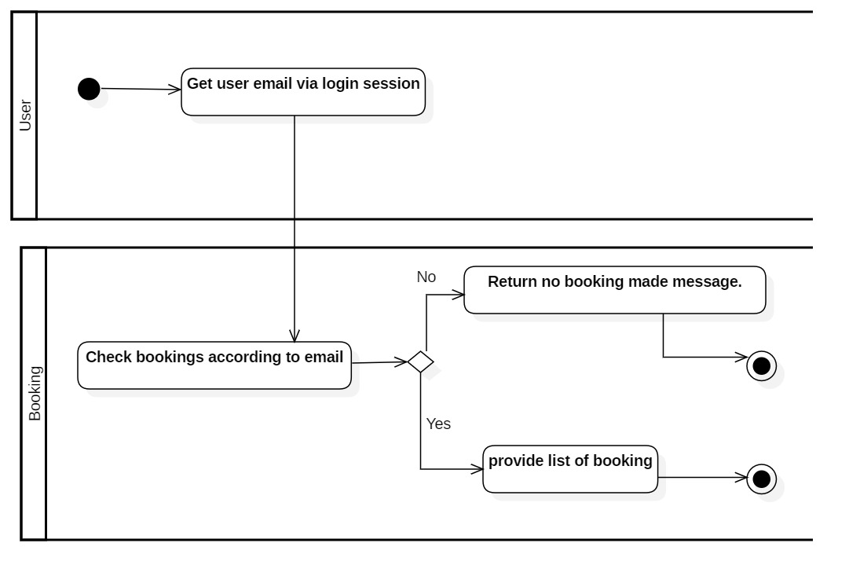

**Activity Justification**

This activity explains about process that takes in place for displaying booking that client had been made.

Firstly, after log in system will get user email via session and when user clicks on page that display their booking, system will check every list of booking made via that email id. If no result is found with that id then it will show message saying they have no booking made and if it found results in booking list then it will display every booking made by them in respective web page.

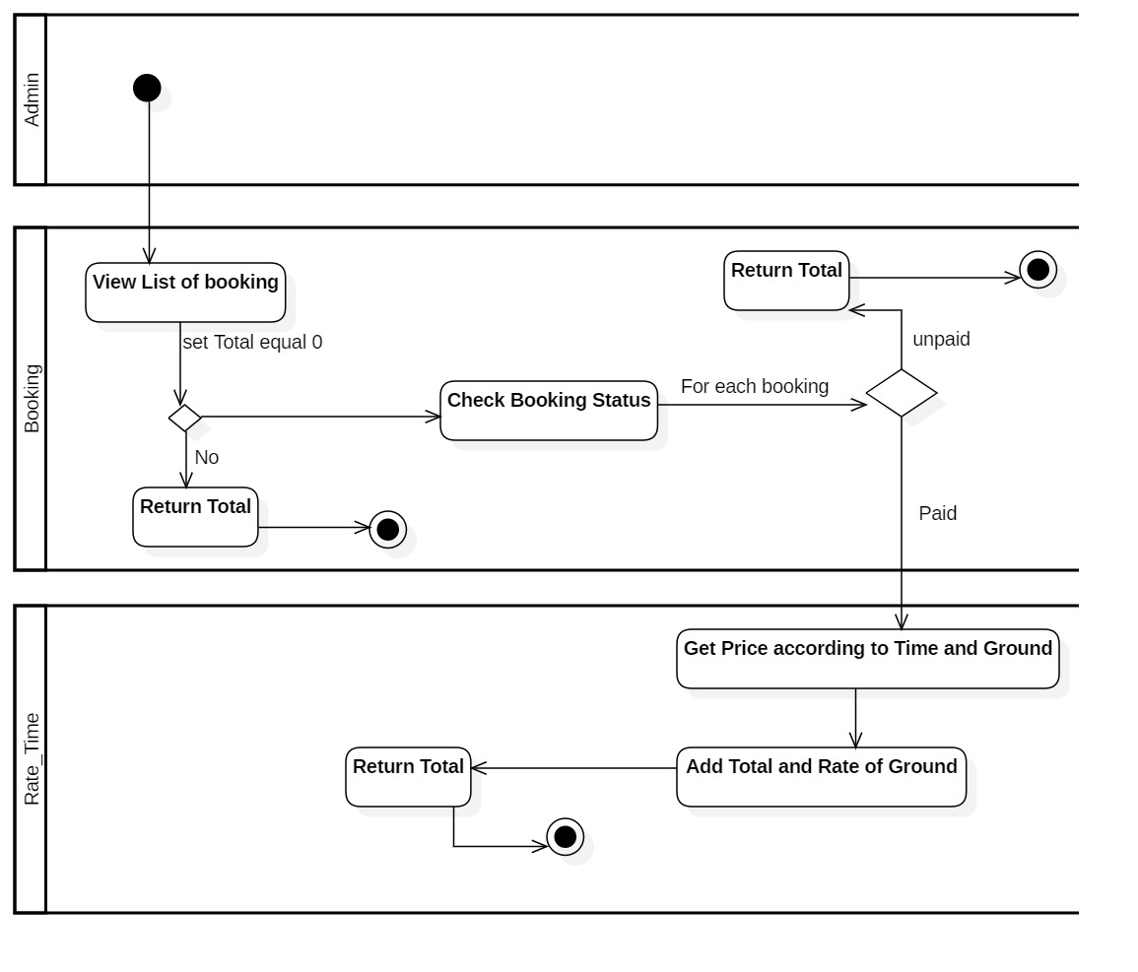

**Activity Justification**

This activity shows that how admin can calculate total amount that they earned via booking. Here admin will list all bookings and after listing all booking. If booking were made then system will return 0 as total value and if booking exists then it will sum all prices of that booking whose status are paid if not paid then system will return 0 as total. Finally, total sum is returned as their earning.

## Sequence Diagram

## 

**Justification**

Firstly, when user gets authenticate and access to their respective dashboard, he can access to their booking list that they made. Here, user goes to bookings and system checks if booking available or not automatically. If they had got their booking list then he will be provided with booking delete option where he can delete his booking. When he deletes their booking system will remove booking from booking table and provide respective booking list respectively.

## 

**Justification**

Here, user request for access to booking page where system ask to provide Valid Email and Password. Then, user provide valid user email and password. Now, system processed for authentication for provided user email and password. If it gets authenticate successfully then they request for available time. Again, system ask them for Date and Ground for booking and then user provide date and ground as their interest. Now, system will Provide available list of timeslots. Finally, user select timeslot as their interest and submit booking and system will add that booking to database and return success message.

However, if user doesn’t get authenticated then system return invalid authenticate message and ask them to provide valid Email and password.

# UI Design

Home

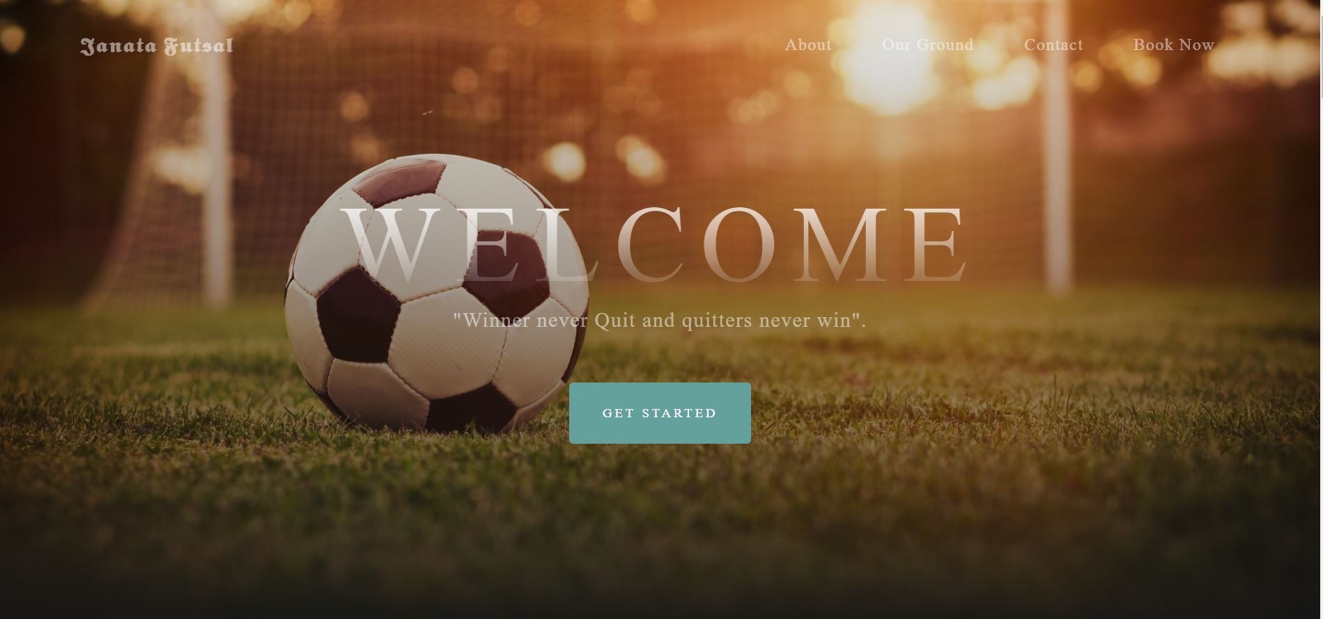

Login

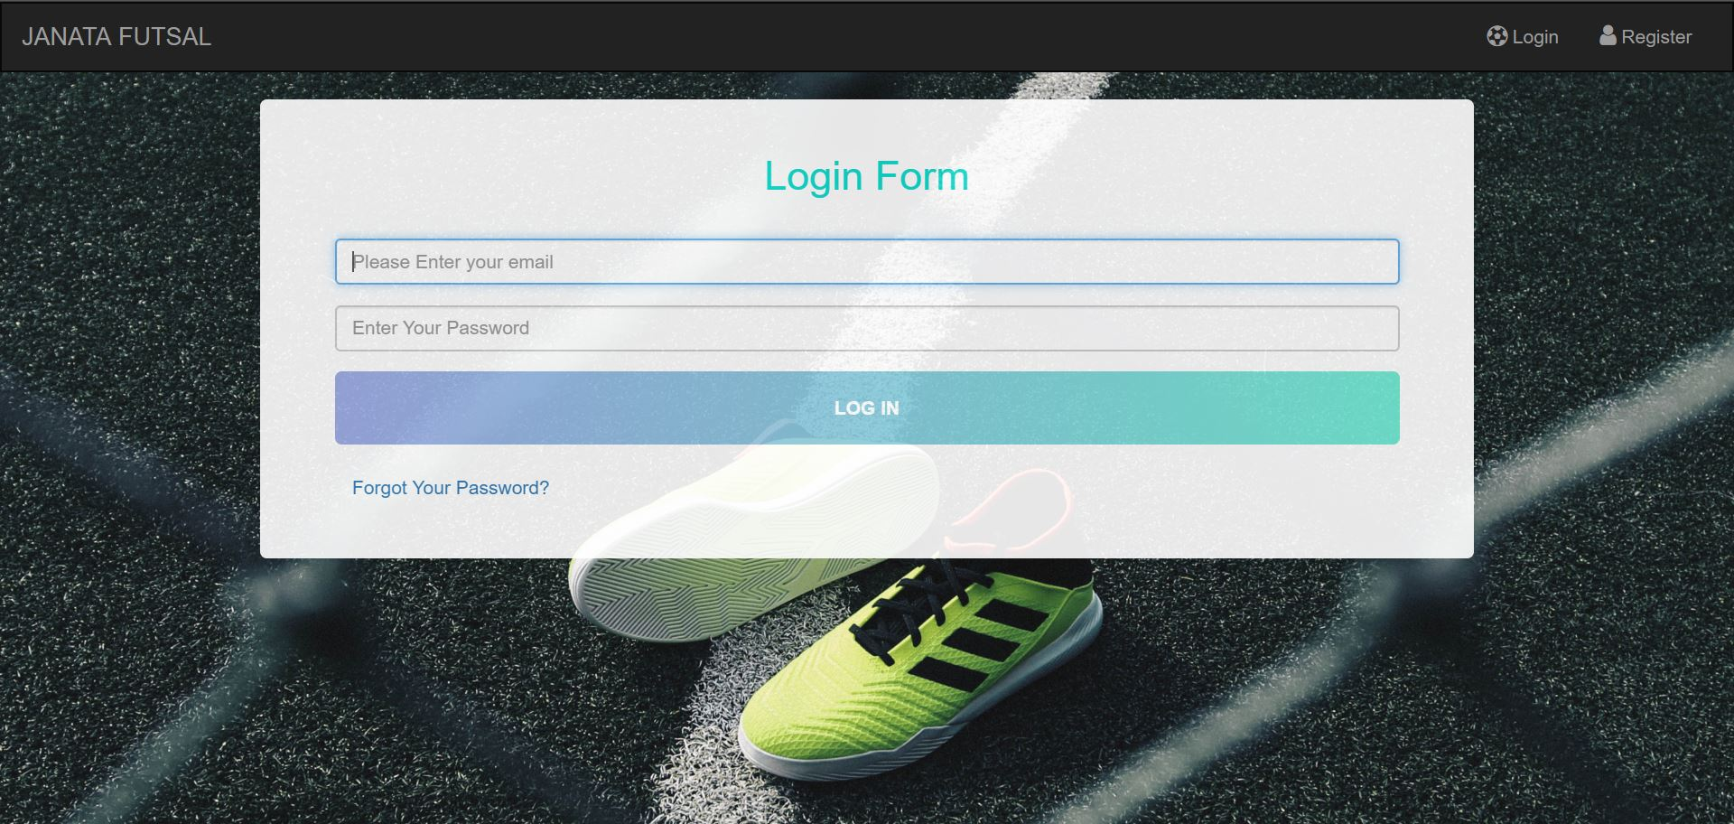

Registration

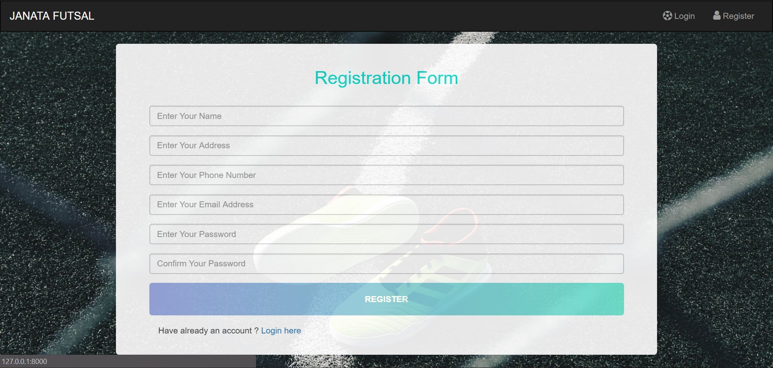

Admin Dashboard

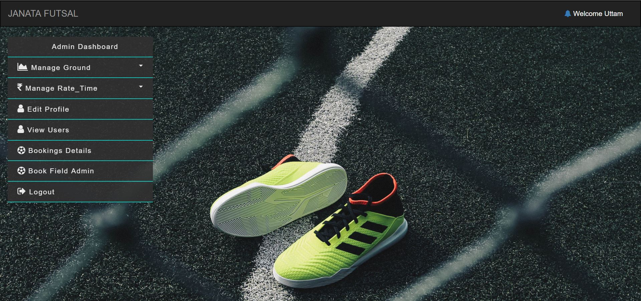

Client/Customer Dashboard

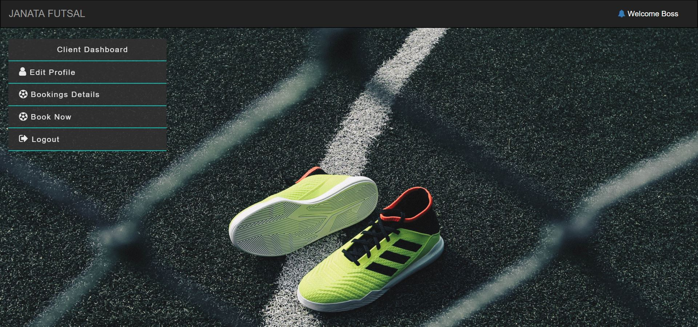

# Database Design

The Entity Relationship Diagram is simply a graphical way of representing data and their relationship with other data. Normally defines how entities like objects, peoples, concepts are related to each other. Three types of methods are present in order represent data using ER diagram, they are UML, Crows Feet and CHEN. I produced EG Diagram using Crows Feet method using software known as Oracle Visual Paradigm.

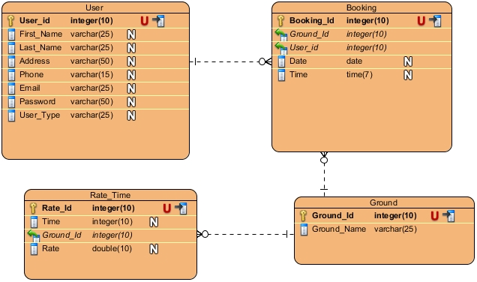

# Chapter 5

# Implementation

# Chapter 6

# Testing

## Unit Testing

## Black Box Testing

Test 1: Login for Admin

Result: Pass

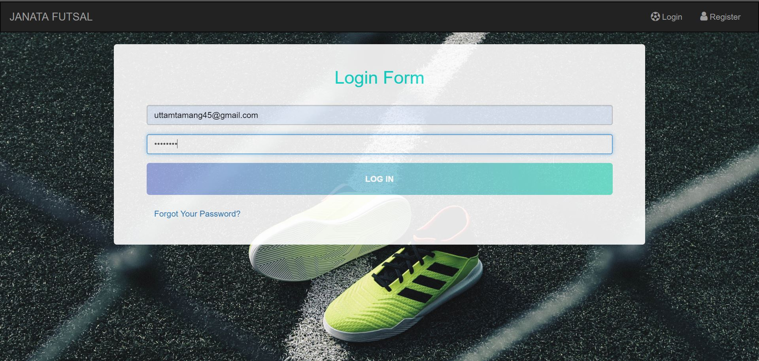

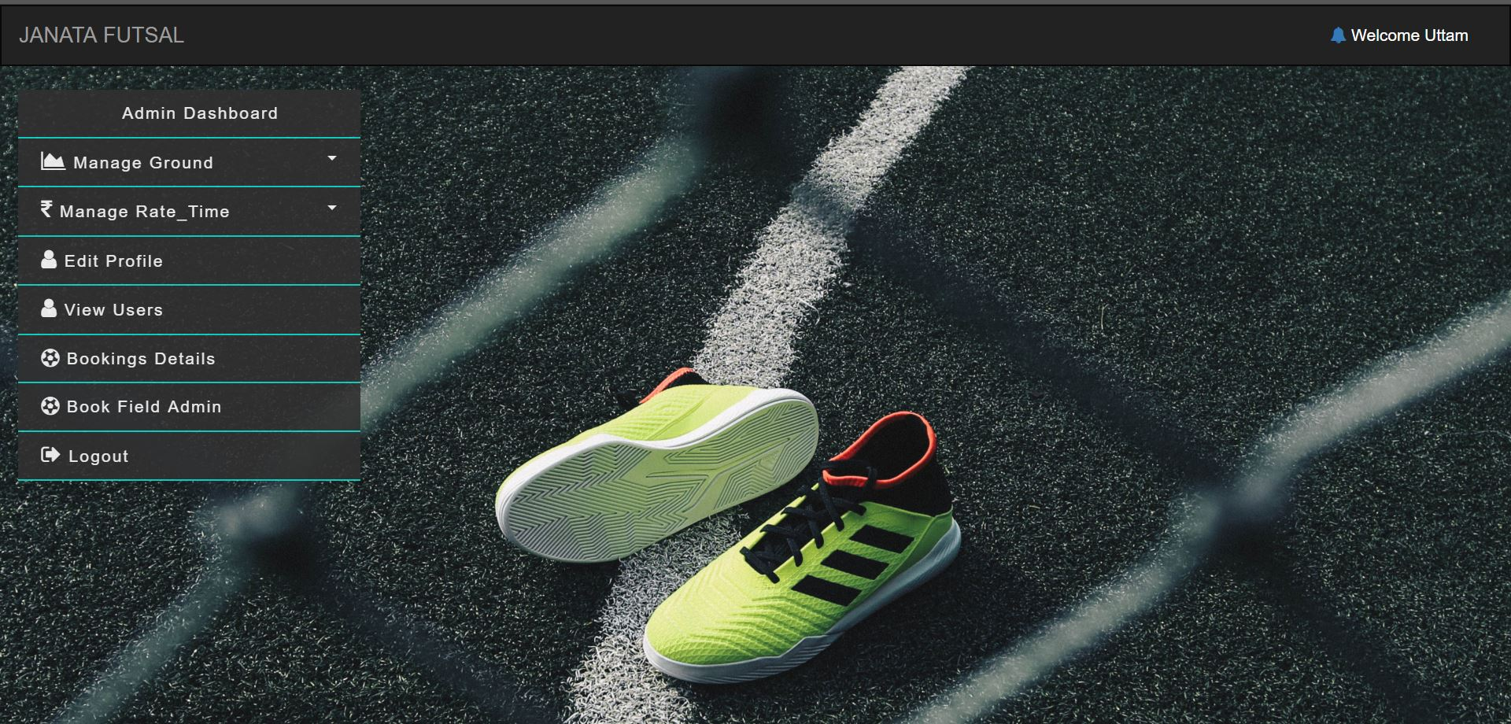

Test 2: Login for Client/Customer

Result: Pass

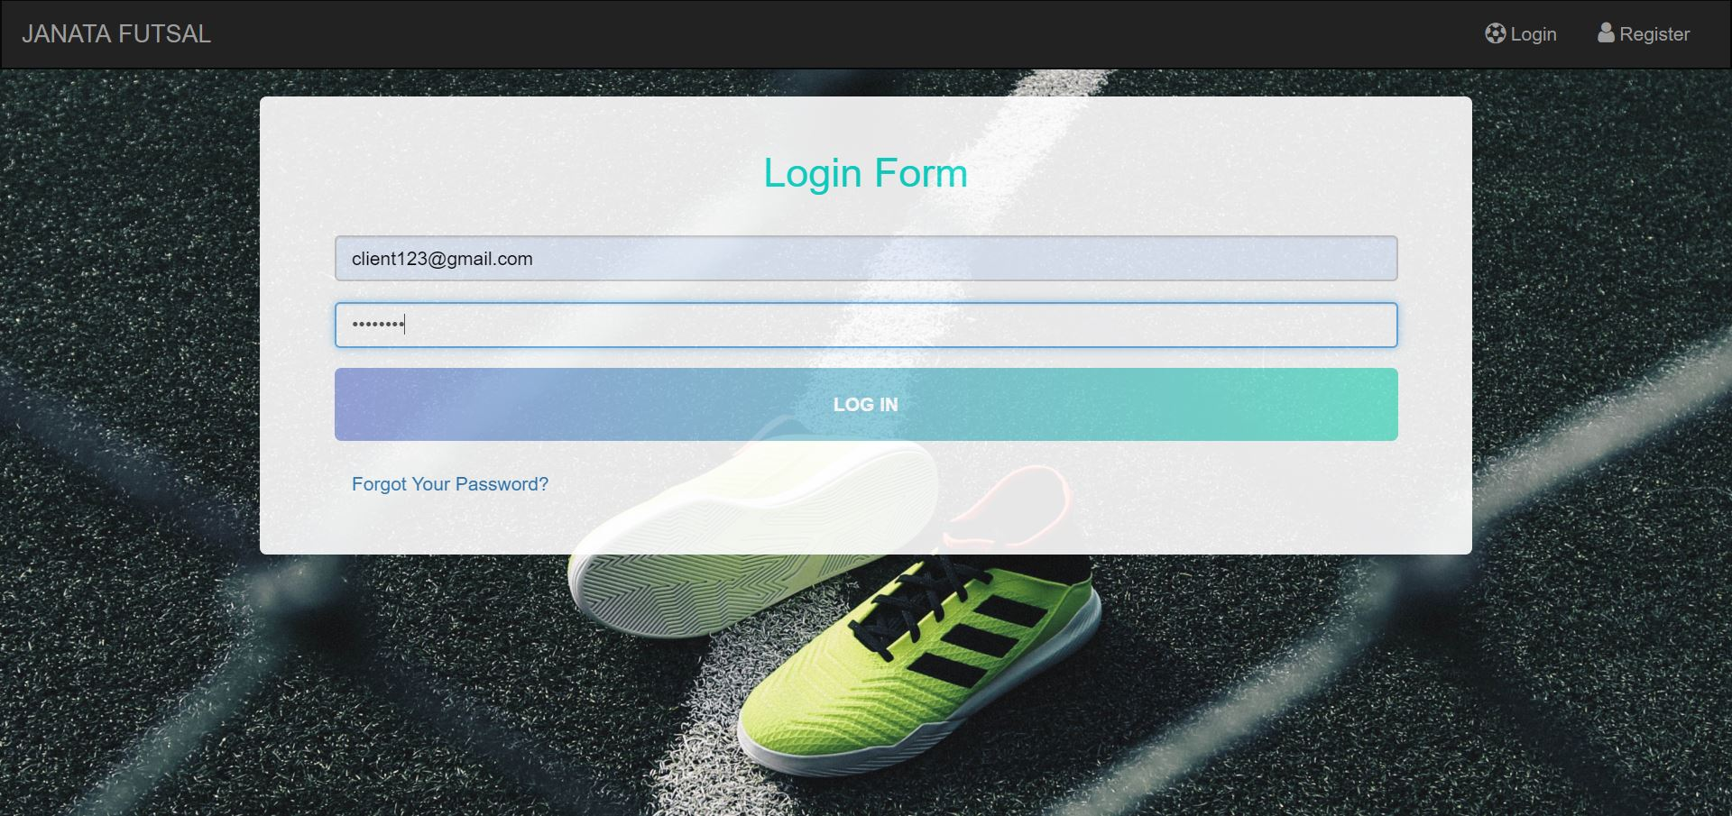

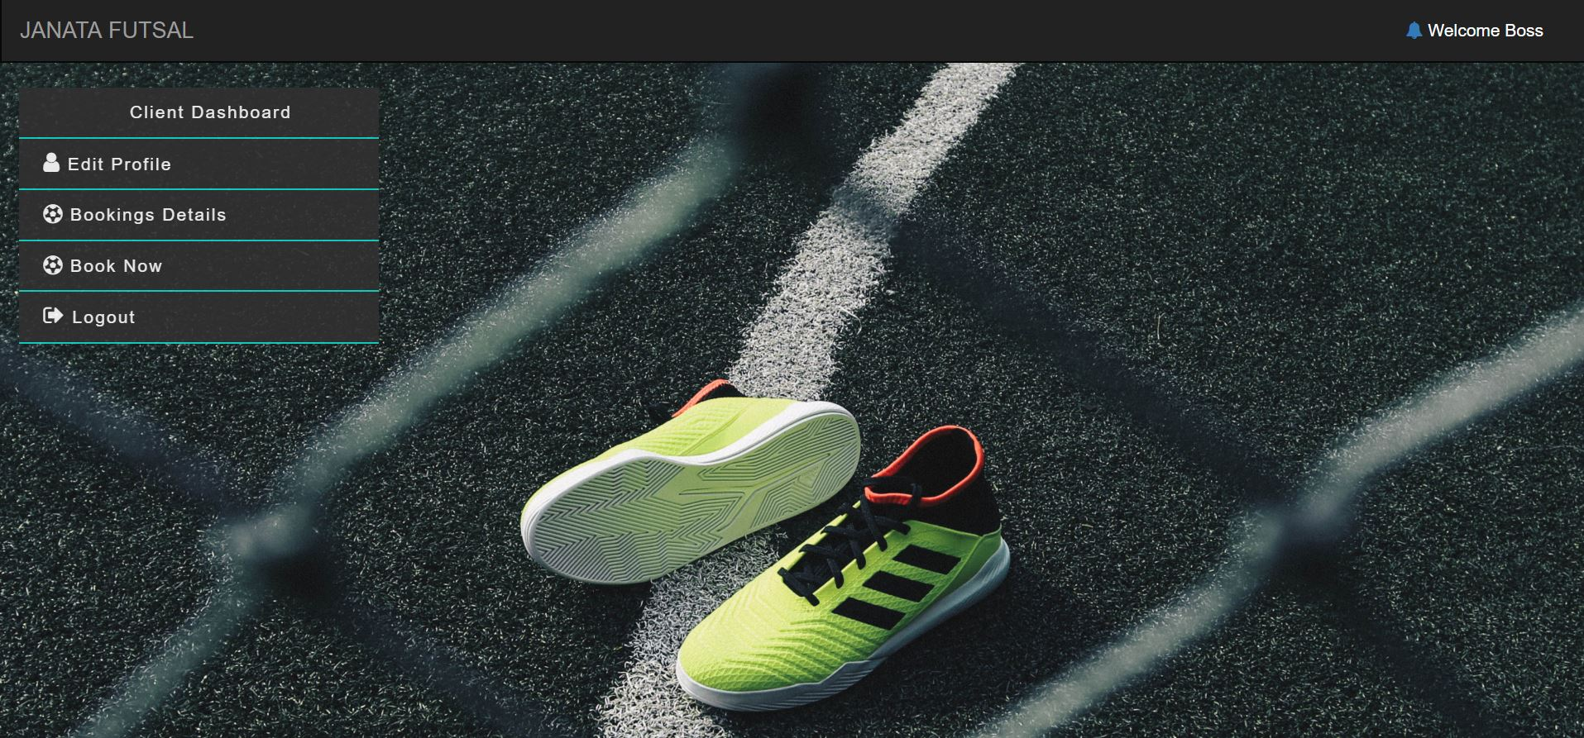

Test 3: Edit Profile

Result: Pass (Name changed from boss to Update)

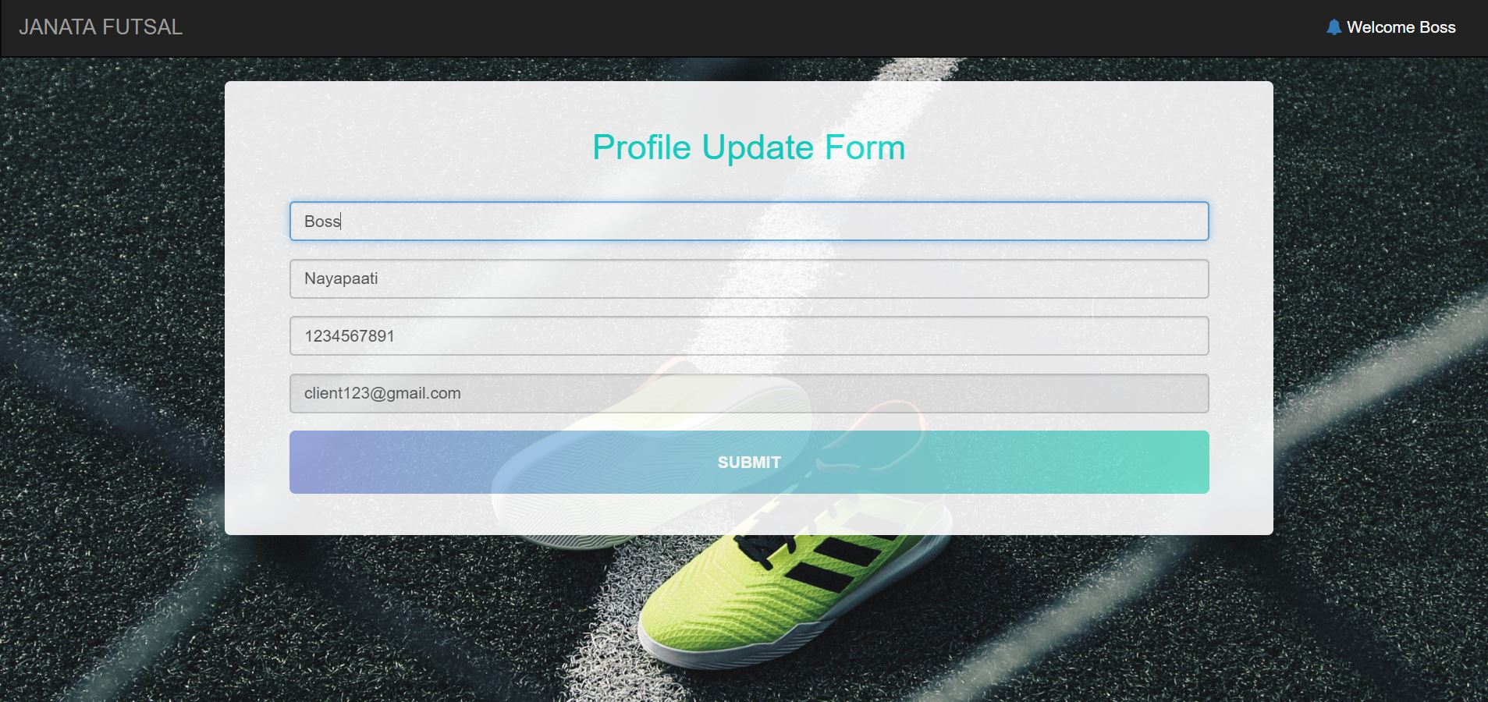

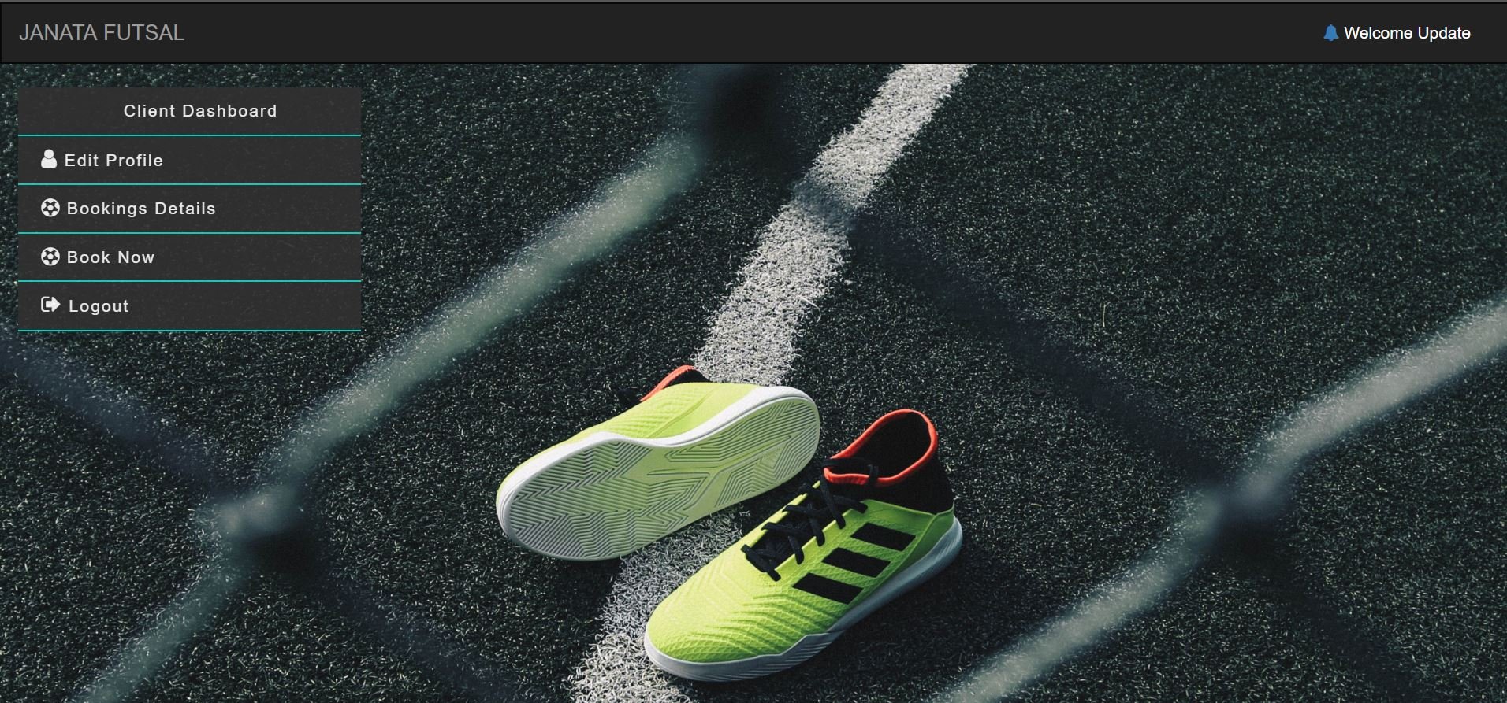

Test 4: Adding ground by admin

Result: Pass

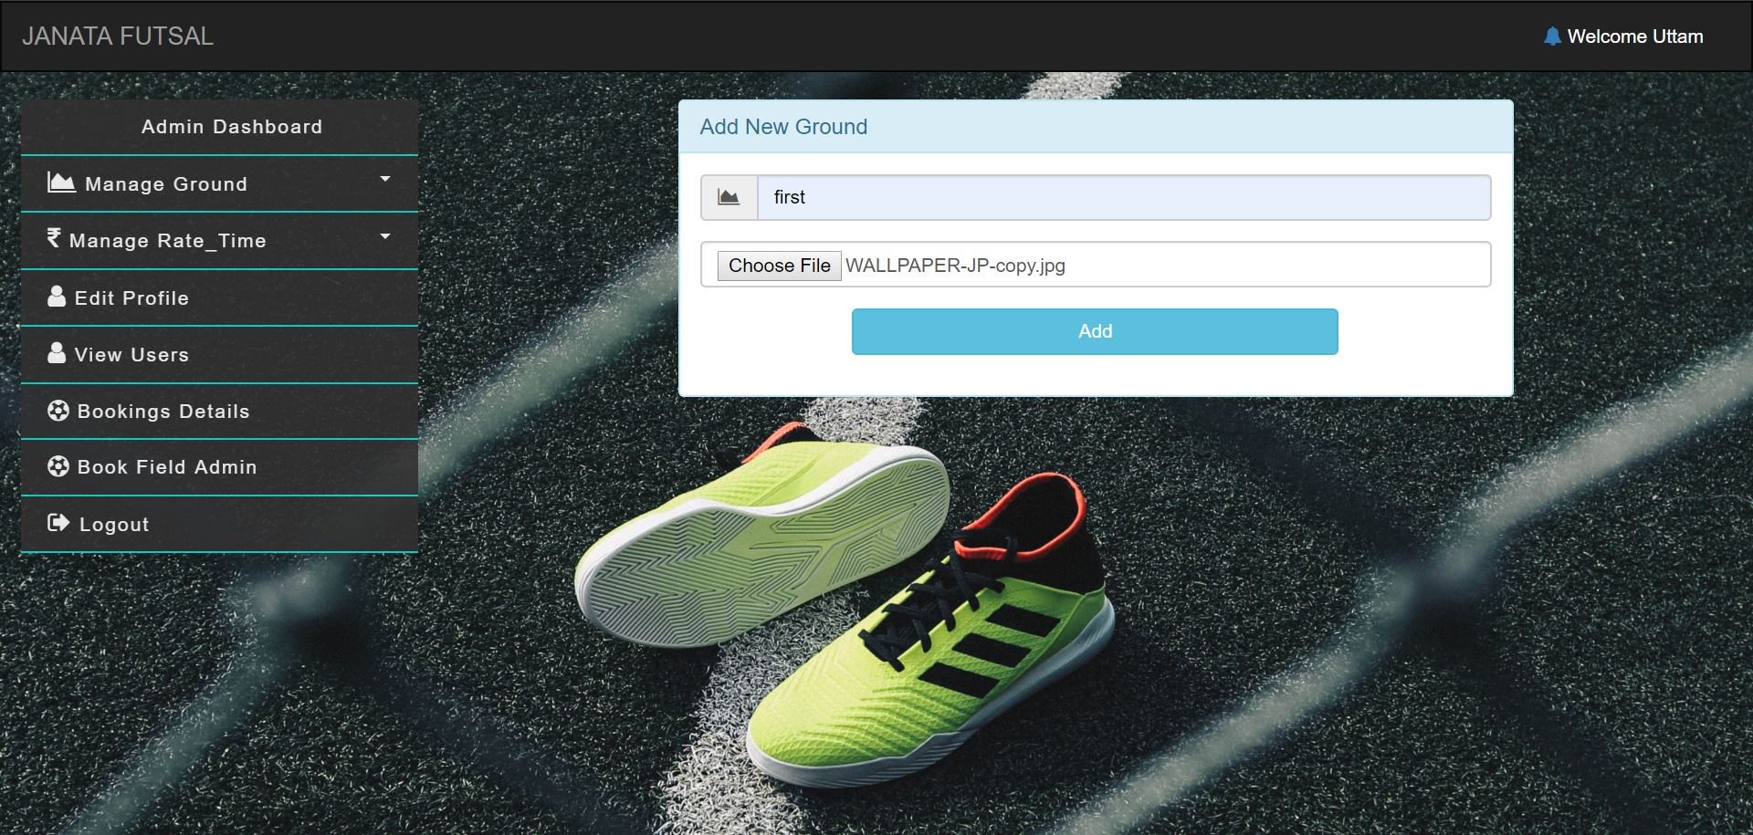

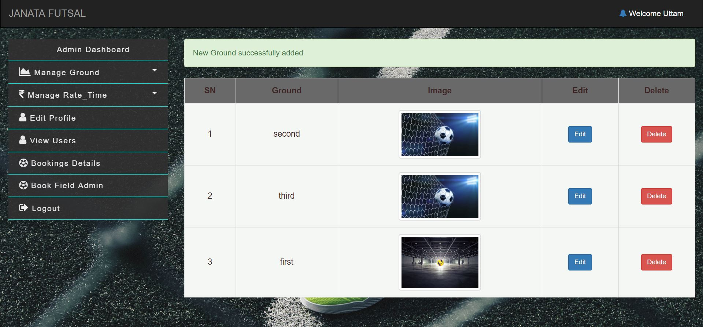

Test 4: Updating Ground

Result: Pass

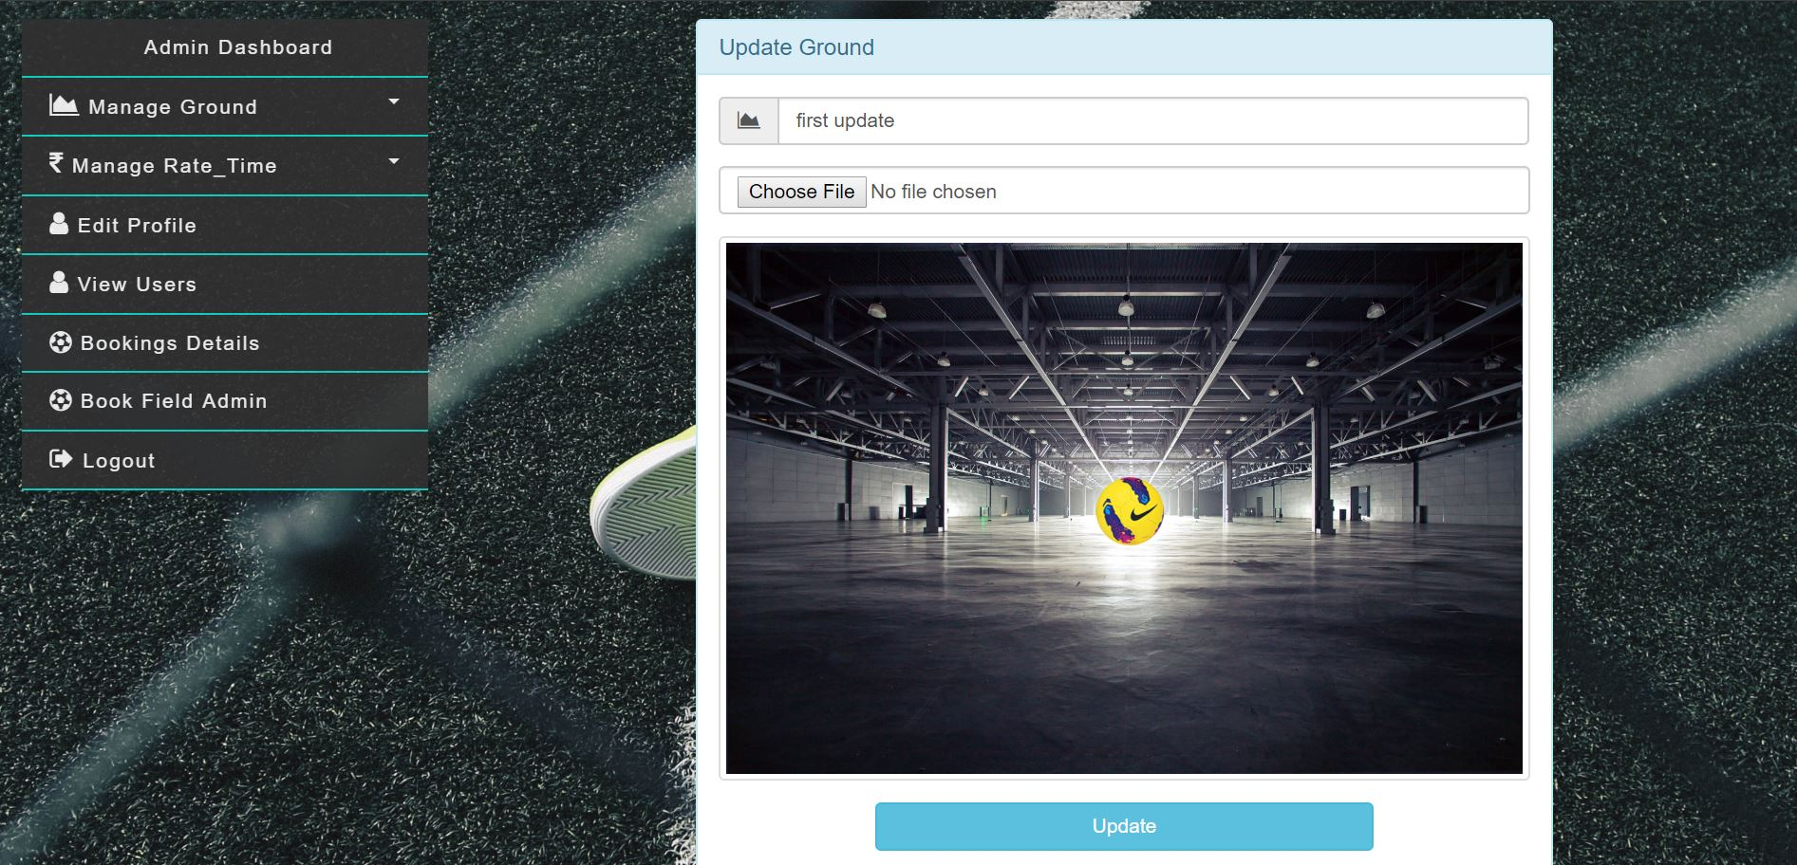

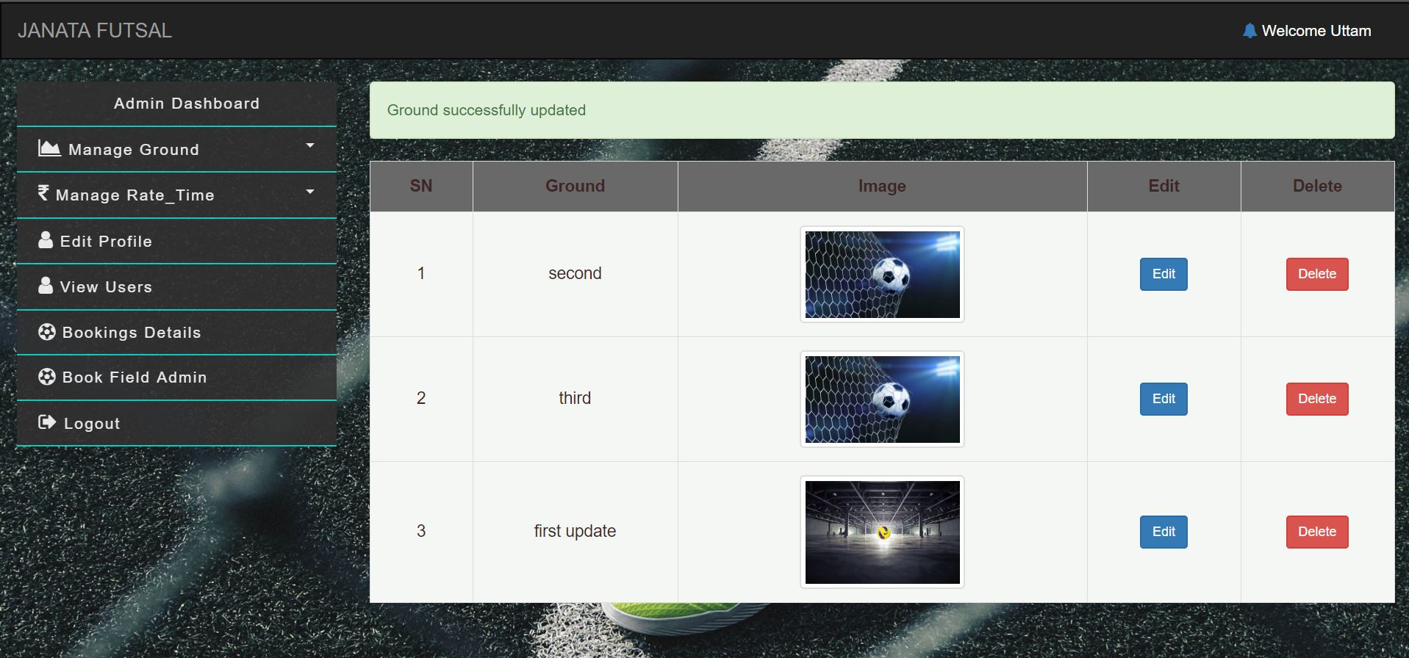

Test 5: View User for Admin (All as well as Specific)

Result: Pass

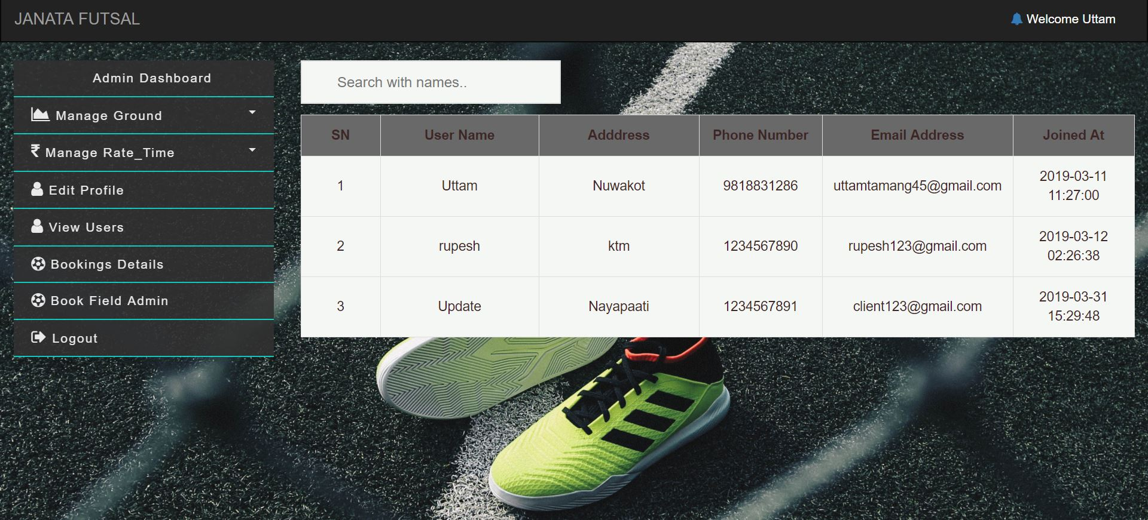

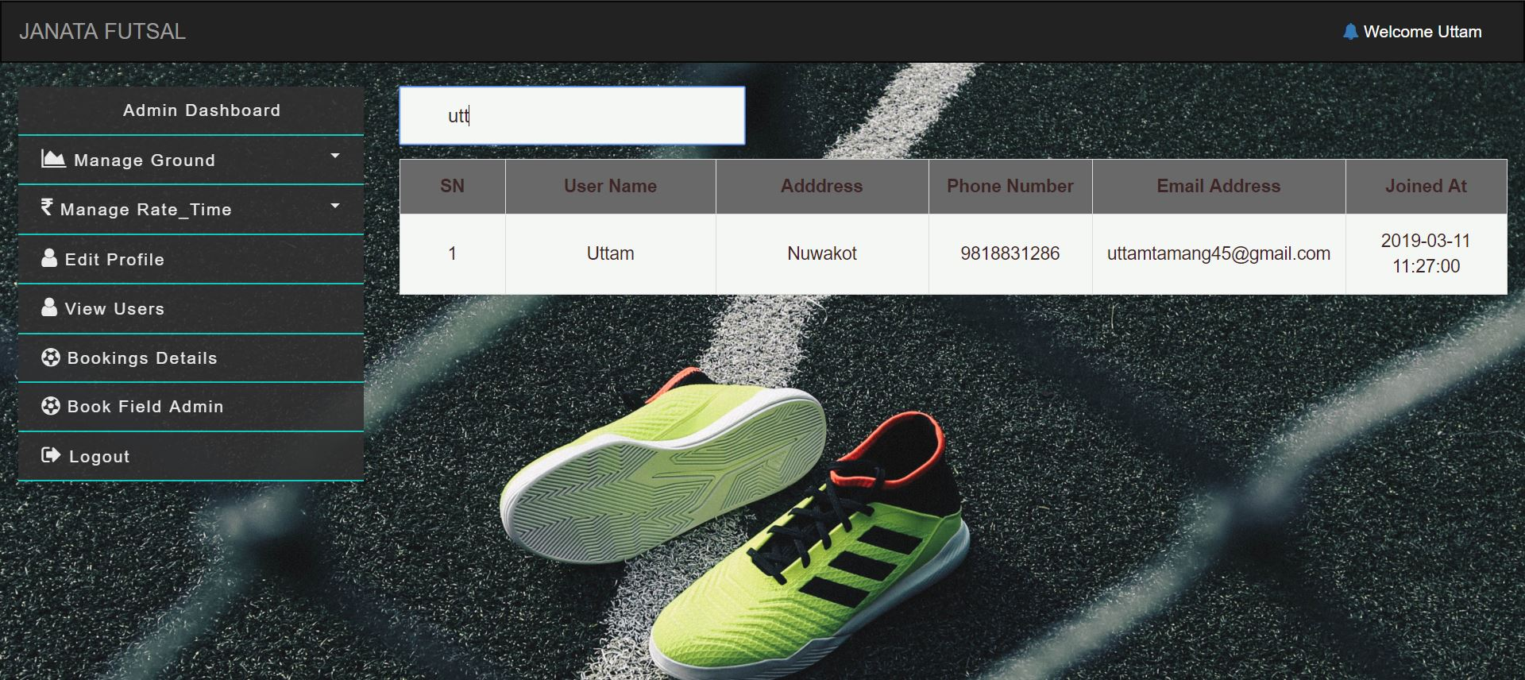

Test 6: View Booking list with Total collection

Result: Pass

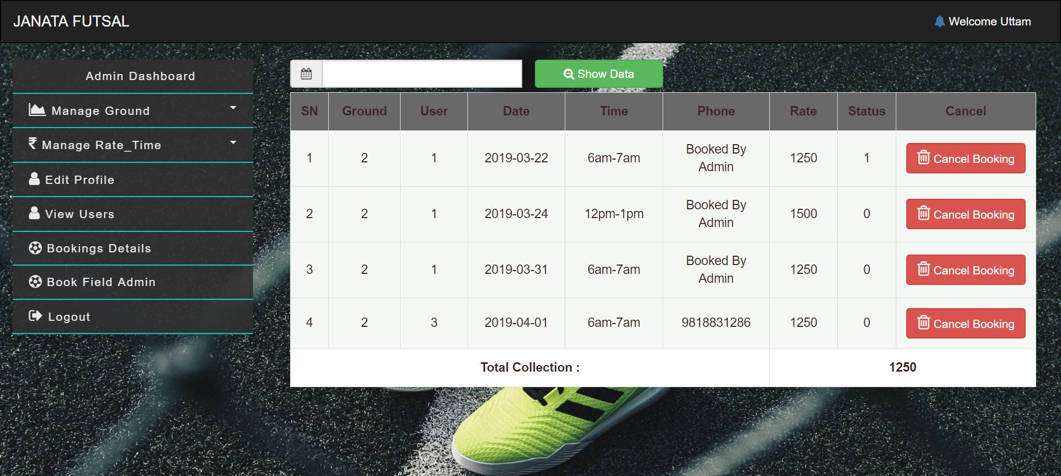

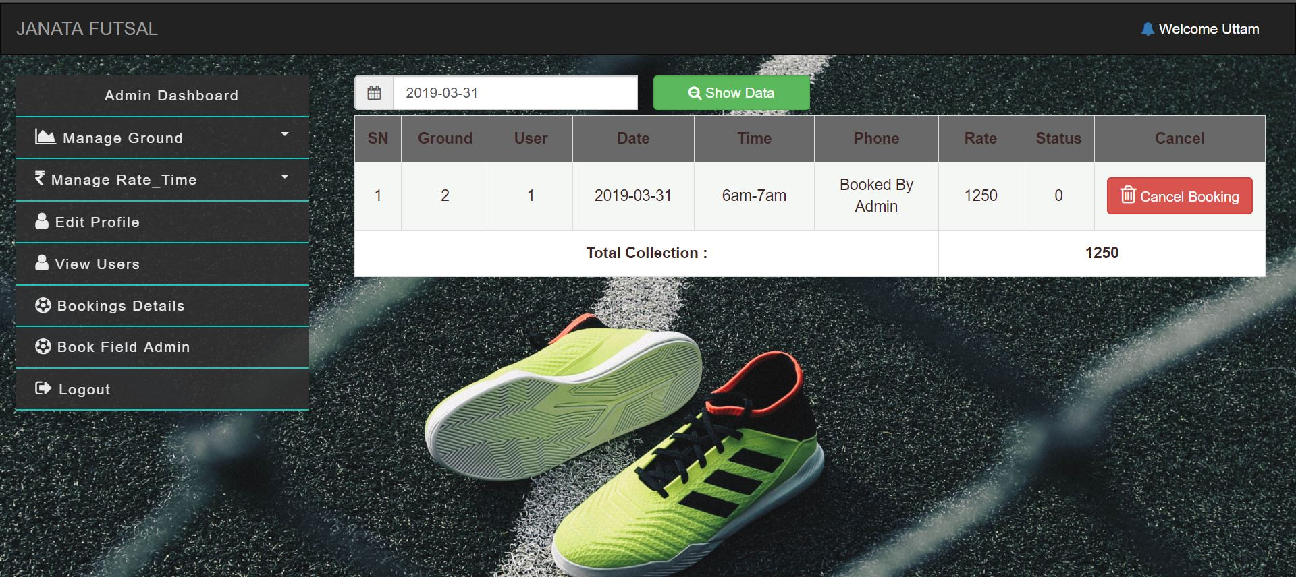

Test 7: Checking Available Time

Result: Pass

Note: Red button shows Booked time and Blue Button represent Available time.

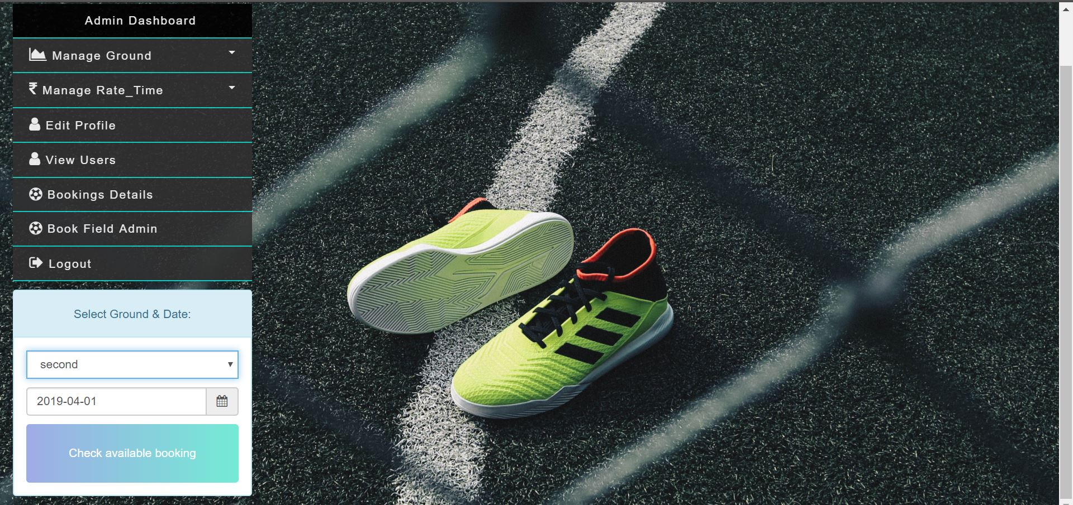

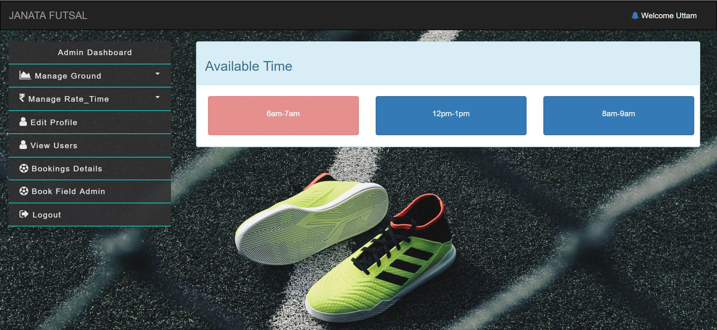

Test 8: Client Booking

Result: Pass

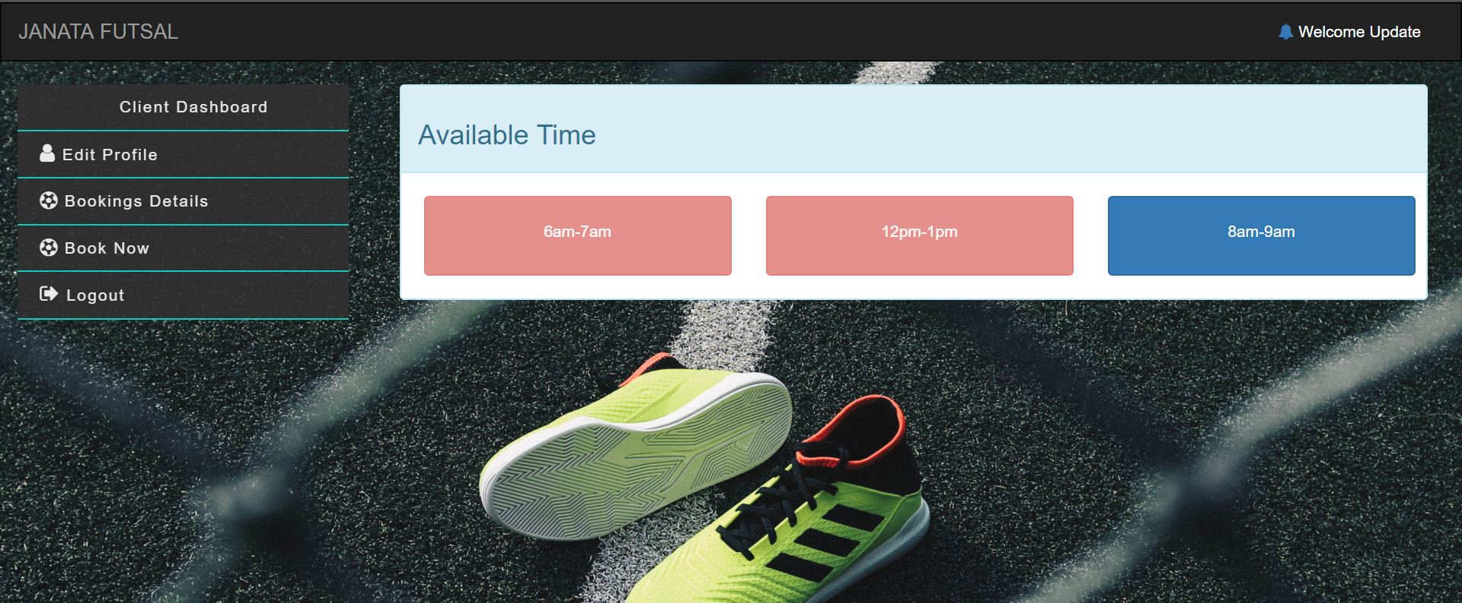

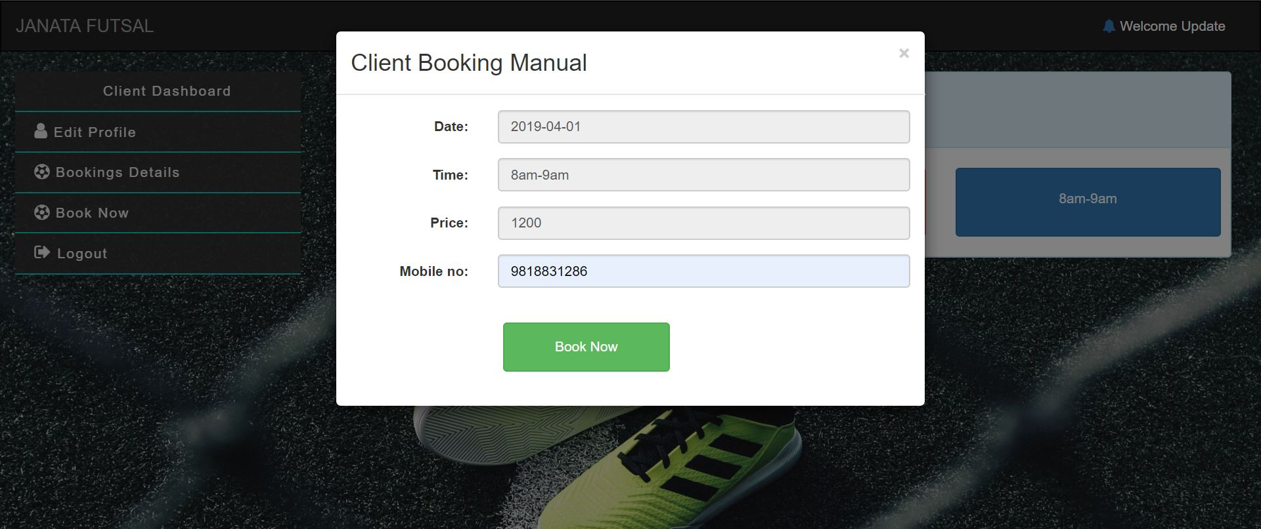

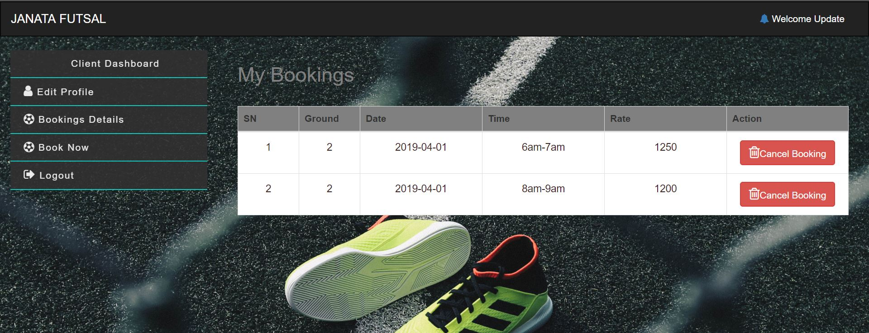

Test 9: Client Booking Cancel

Result: Pass

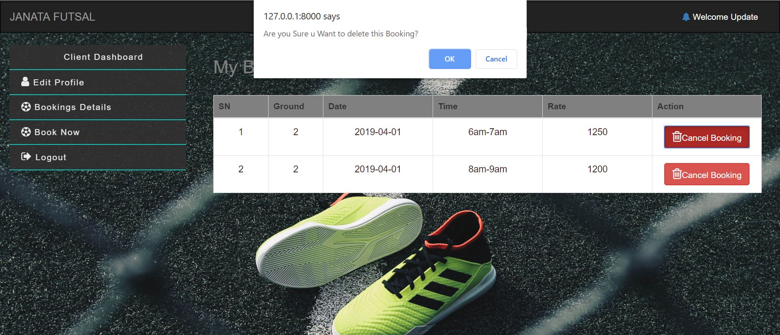

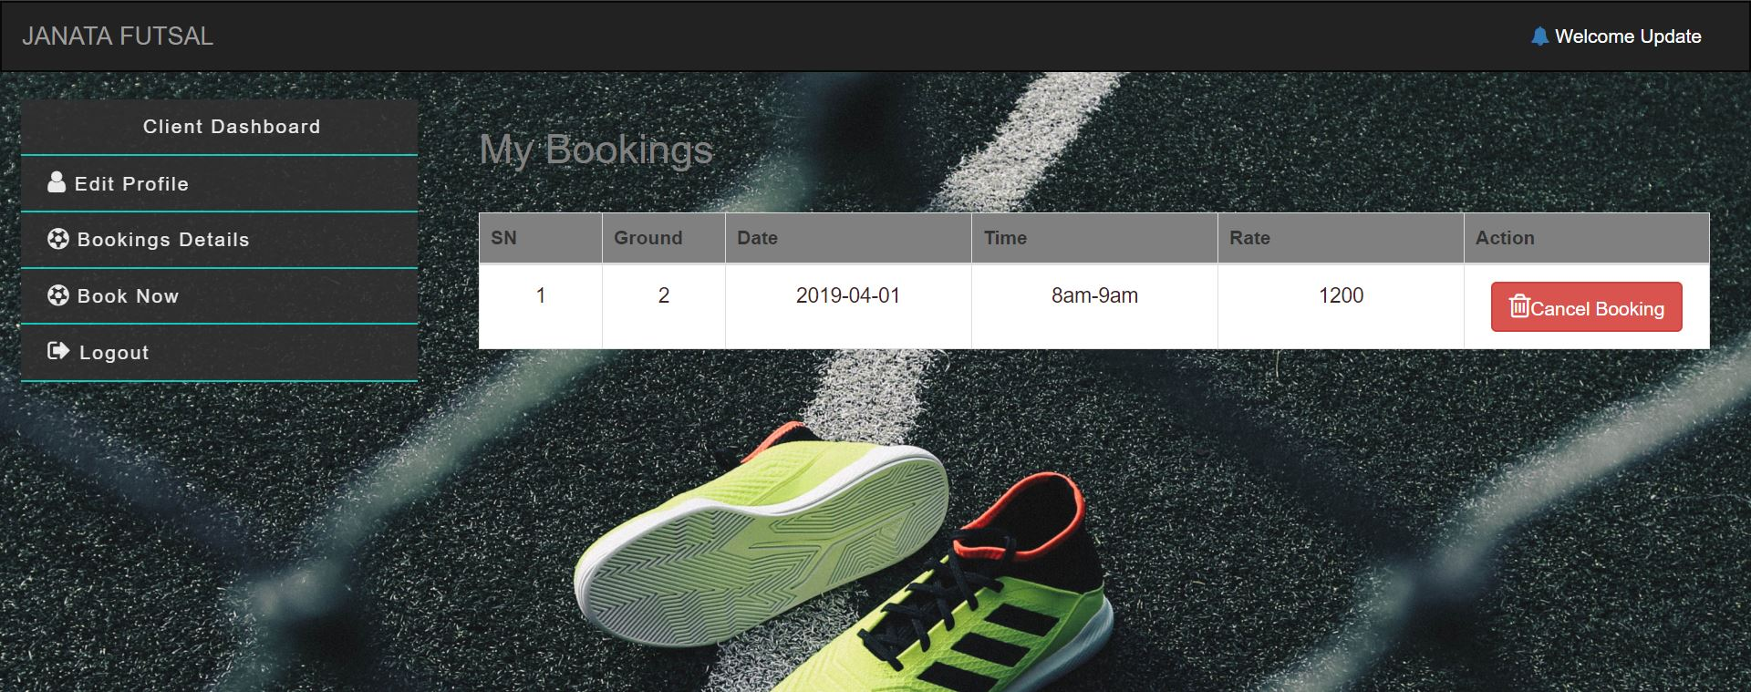

# Conclusion

Finally, desired Web Application for futsal booking management is created successfully. Which will now automate online registration, booking and management functionality for both clients and Admins. As per requirement application meets most of functionality ( All from Must Have Functionality and some from Should Have and Could Have ) we listed on MoSCoW list.

However, many of necessary functionality lacks in solution. Which will fixed from future update.

# References

Anon., 2018. *izenda.com.* [Online]   
Available at: https://www.izenda.com/blog/5-benefits-3-tier-architecture/  
[Accessed 03 01 2019].

Anon., 2018. *simplicable.com.* [Online]   
Available at: https://simplicable.com/new/system-architecture-definition  
[Accessed 03 01 2019].